인공지능플랫폼 최적화 HW 03

2021234640 이종현

**[Step 1] Getting Started**

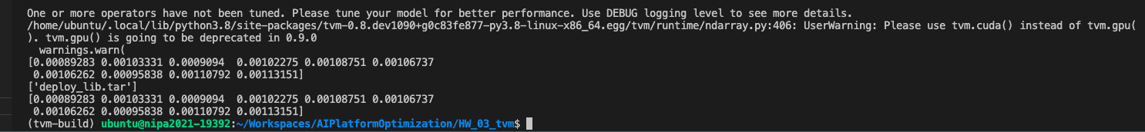

**[Step 2] Tensor Expressions and Schedules**

1. **Matrix Multiply Default**

**(2-1) Split with factor**

**(2-2) Split with nparts**

**(3) Tile**

**(4) Fuse**

**(5) Reorder**

**(6) Bind**

**[Step 3] OptimizationTensor Operators**



**[Step 4] Relay Pass Infra**

**[Step 5] VTA Simulation**

